SOFTWARE TESTING
- FUNCTIONAL
- NON-FUNCTIONAL
  - Usability aspects
  - Compatibility
  - Security
  - Performance

- POSITIVE TESTING
  - Performance
- NEGATIVE TESTING

- MANUAL TESTING
- AUTOMATION TESTING
  - Performance

- BBT
  - Performance
- WBT
  - Performance
- GBT

PERFORMANCE TESTING is
- Non-Functional testing
- Positive testing
- Automated testing
- BBT & WBT
What is Performance Testing ?
It is a non-functional testing aimed to validate the server behavior when various clients of different configurations (OS, browser, mobile landscape, network connectivity, ip-address, geo-location) bombard the server with various types of requests, by automating the positive business work-flows.
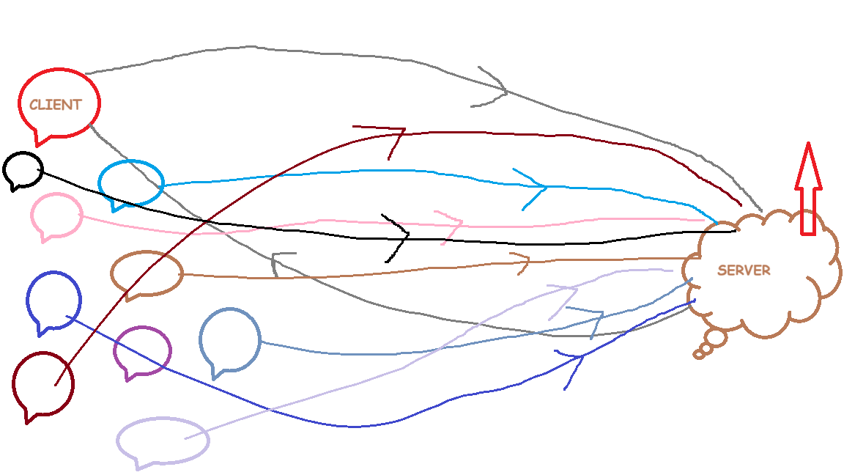

Types of Performance Testing
- Response time testing > vUser=1
- Load testing > vUsers > 1 [to evaluate server]
- Stress testing > vUsers > 1 [to find client’s break-even point i.e., do they time-out when they fail to get server response] [to evaluate client]
- Endurance/Soak testing > vUsers > 1 ; time-bound activity

PERFORMANCE KPI METRICS TO MEASURE:
- Connection time : the time taken by client to establish a valid secured connection with the server, before sending the client request
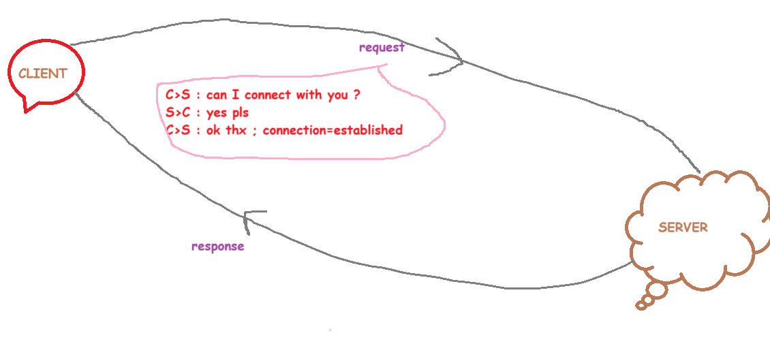
- Latency : the time taken by server to send 1st packet/byte to the client
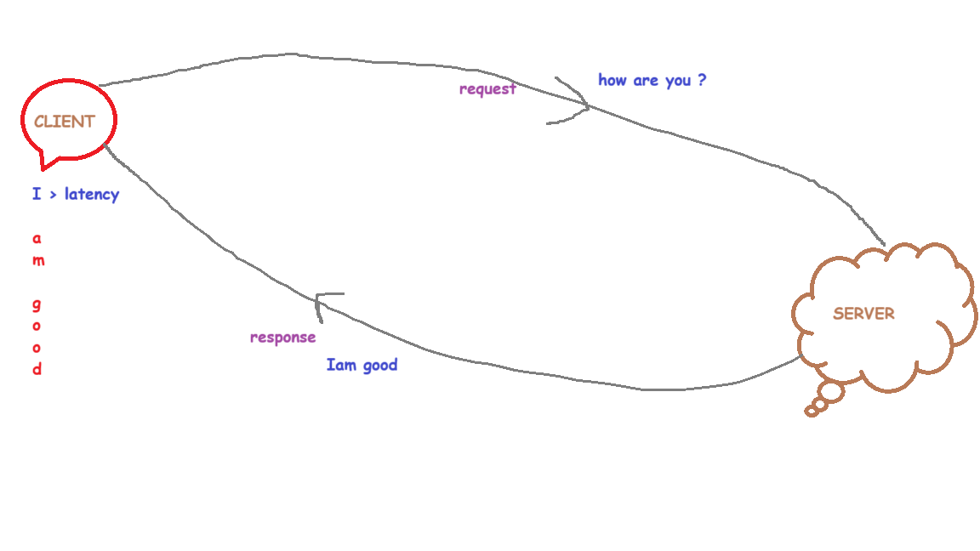
- Average response time : the time taken by server to send all packets (complete response) to the client

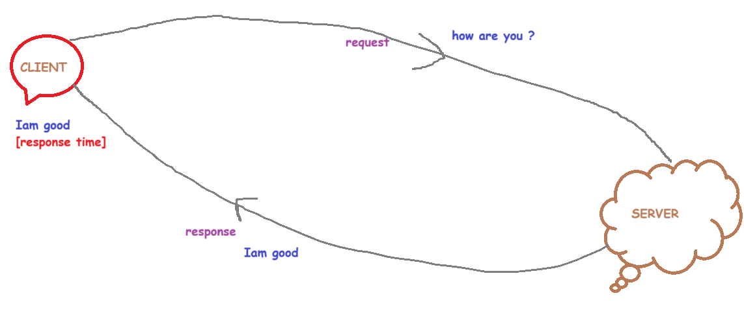
- 99% percentile response time : the time taken by server to send all packets (complete response) to the client and this is computed only for top 99% of the requests sent
- 95% percentile response time : the time taken by server to send all packets (complete response) to the client and this is computed only for top 95% of the requests sent
- 90% percentile response time : the time taken by server to send all packets (complete response) to the client and this is computed only for top 90% of the requests sent
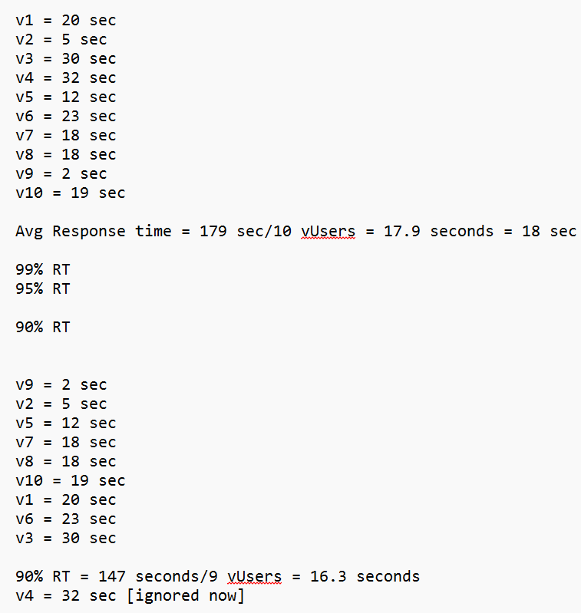
- Server throughput : it is the # of responses per second sent by server to the client(s)
- Client throughput : it is the # of requests per second sent by client to the server
- Error % : it is the % of errors (client side errors, server side errors) received during performance testing activity
- CPU % utilization : it is the % of CPU utilization on the server measured during performance testing activities ; ideally, CPU% should be below 90% utilization
- RAM % utilization : it is the % of RAM utilization on the server measured during performance testing activities ; ideally, RAM% should be below 90% utilization
- Size sent : it is the size of client request sent to server
- Size received : it is the size of server response sent to client
- Response code : it is a 3 digit status code sent by server to the client, to reveal the status of client request

CLIENT & SERVER ARCHITECTURE
- Every request sent by client is associated with
  - Protocol
    - http [unsecured]
    - https [secured]
  - HTTP methods
    - Get [to retrieve/fetch existing data from the server]
    - Post [to create new data on the server]
    - Put [to update the existing data on the server]
    - Patch [to update the existing data on the server]
    - Delete [to delete the existing data on the server]
  - Request Headers
    - User-Agent : origin of client request
    - Connection : keep-alive, close
    - Content-Type : format of client request being sent to server such as json, xml, html, text, yaml
    - Authorization : login credentials in the form of access token
- Every response sent by server is associated with
  - Response Headers
    - Date
    - Content-Type
    - Cookies
    - Cache
  - Response Code
    - Range: {100-599}
      - 100-199 > 1xx > informational responses
      - 200-299 > 2xx > successful responses
      - 300-399 > 3xx > re-directional responses
      - 400-499 > 4xx > client-side errors
      - 500-599 > 5xx > server-side errors
  - Response Message

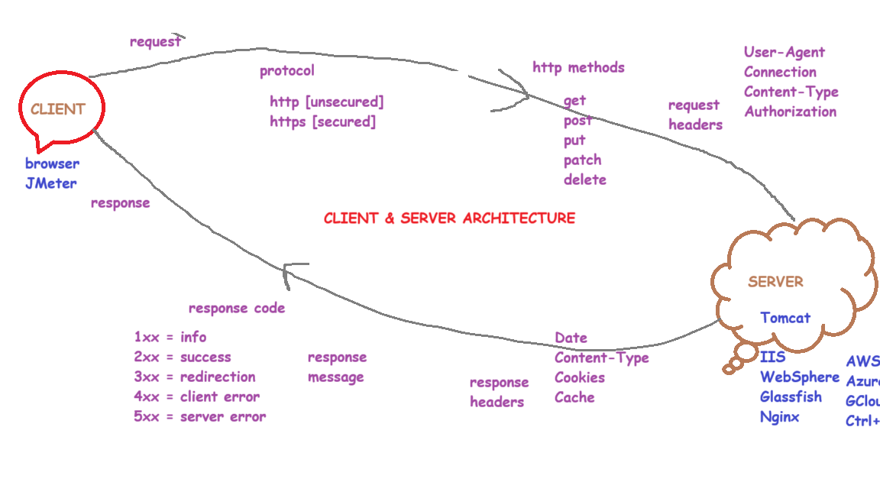
WHAT/WHY IS JMETER ?
- JMeter is a performance testing tool
- It is an open-source tool built on java
- It can be used to test various protocols
- It has a simple & clean GUI interface
- It can work from CLI mode as well
- It can generate test reports in .csv & .html format
- It can be integrated with CI/CD tools like Jenkins
- It has lot of in-built plugins [~ 110]
- It involves less/no coding and is fully focused on configurations to conduct performance testing

JMETER DOWNLOAD
https://jmeter.apache.org/download_jmeter.cgi
Download > Unzip > bin folder >
double click on ApacheJMeter.jar
or
double click on jmeter.bat
or
open cmd prompt > bin folder > ApacheJMeter.jar
or
open cmd prompt > bin folder > jmeter.bat

JMETER TEST PLAN ELEMENTS
- Thread Group : Here, we define
  - # of vUsers/threads
  - Ramp-up duration
  - Loop count/iteration
- Samplers: these are the client requests
- Listeners: these will capture server responses & presents KPI metrics
- Config elements:
- Assertions
- Timers
- Logic controllers
- Pre-Processors
- Post-Processors
- Test Fragment
- HTTPs test script recorder
PROBLEM STATEMENTS
- Develop a performance test plan in JMeter tool to test a simple web page for 1vUser
https://cms.co.in/
- Develop a performance test plan in JMeter tool to test a simple web page for 5 vUsers with ramp up = 2 seconds
https://cms.co.in/
https://cms.co.in/career-ceo

- Develop a performance test plan in JMeter tool to test multiple web pages for 8 vUsers with ramp up = 5 seconds & loop count=2
https://cms.co.in/
https://cms.co.in/aboutus-22_overview-3
https://cms.co.in/clients
https://cms.co.in/IndiaAi.html

- Conduct endurance/soak testing using JMeter on any given web application
https://demo.automationtesting.in/
https://demo.automationtesting.in/Register.html
https://practice.automationtesting.in/
  - vUsers=20
  - Ramp up duration=5 seconds
  - Loop count=60 seconds

- Conduct a load test on a form submission webpage
https://opensource-demo.orangehrmlive.com/web/index.php/auth/login
- Config elements in JMeter
  - HTTP request defaults
  - HTTP cookie manager
  - HTTP cache manager
  - HTTP Header manager > User-Agent
    - Windows OS + Chrome browser
To simulate browser behavior, we use cookie manager, cache manager & header manager in JMeter tool
- Conduct a load test on a given web application by simulating various browsers such as
  - Windows OS + Edge browser
Mozilla/5.0 (Windows NT 10.0; Win64; x64) AppleWebKit/537.36 (KHTML, like Gecko) Chrome/138.0.0.0 Safari/537.36 Edg/138.0.3351.109
  - Mac OS + Safari browser
Mozilla/5.0 (Macintosh; Intel Mac OS X 15_5) AppleWebKit/605.1.15 (KHTML, like Gecko) Version/18.4 Safari/605.1.15
  - Linux OS + Firefox browser
Mozilla/5.0 (X11; Linux i686; rv:141.0) Gecko/20100101 Firefox/141.0
  - Android OS + Chrome browser

Mozilla/5.0 (Linux; Android 10; K) AppleWebKit/537.36 (KHTML, like Gecko) Chrome/138.0.7204.169 Mobile Safari/537.36

  - iPhone OS + Safari browser
Mozilla/5.0 (iPhone; CPU iPhone OS 18_6 like Mac OS X) AppleWebKit/605.1.15 (KHTML, like Gecko) Version/18.4 Mobile/15E148 Safari/604.1
Syntax of a variable in JMeter: ${variableName}
- Usage of Timers in JMeter
To simulate real user behavior, we use timers in JMeter tool
- Constant timer : here, the sampler waiting time is fixed
- Uniform random timer: here, the sampler waiting time is dynamic
- Gaussian random timer: here, the sampler waiting time is dynamic
- Poisson random timer: here, the sampler waiting time is dynamic

- Config elements are executed first in the JMeter thread group
- Timers are executed first before the samplers

- Usage of Assertions in JMeter
Assertions in JMeter are used for functional validations on the server response received, during performance testing.
Assertions are executed only after receiving the server response.
- Response code assertion
- Response message assertion
- Duration assertion
- Response size assertion
- Response headers assertion
- Response body/text assertion

- Usage of variables in JMeter tool
Variables acts as containers to hold object values
${variableName}
We can create variables in JMeter at below levels:
- Test Plan level
- Config element > User defined variables
- preProcessor > User parameters
  - preProcessor is always added as a child element to a sampler
  - preProcessor is always executed first before the sampler

- Conduct a soak/endurance test on a website by clicking on all possible links in that website
https://cms.co.in/
https://cms.co.in/aboutus-22_overview-3
https://cms.co.in/aboutus_leadership_25
https://cms.co.in/businesses-4_4
https://cms.co.in/services-5
https://cms.co.in/industries
https://cms.co.in/clients
https://cms.co.in/someRandomText
Regular expression: (.*?)
https://cms.co.in/(.*?)
- preProcessor > Sample timeout

this element will timeout and fail the request if the server doesn’t respond in the specified time

- setUp thread group > this thread group will be executed first before executing the main thread group
- tearDown thread group > this thread group will be executed in the last after executing the main thread group
setUp thread group > thread group > tearDown thread group
- multiple thread groups

To run multiple thread groups in sequential order, on the test plan, select the checkbox ‘Run thread groups consecutively’

- Custom thread groups

Download pluginsmanager.jar file > lib/ext > restart JMeter > options menu > plugins manager

- Logic Controllers
  - Once only controller
  - Loop controller
  - Random order controller
  - Random controller
  - Runtime controller
  - Throughput controller : used for distributed load testing across all the vUsers
  - Transaction controller : here, all vUsers will execute the requests together in a parallel manner
  - Critical section controller : here, all vUsers will execute the requests in a sequential manner
  - If controller
  - Module controller
HP > RP > WTP > HP > AP > ACP > HP > DDP > VP > CP

  - Include controller
  - Interleave controller

- FTP sampler & FTP request defaults
- SMTP sampler
- Beanshell sampler, Beanshell preProcessor, Beanshell postProcessor
- File download
- File upload
- Save responses to a file
- Counter
- HTTP authorization manager
- Recording options, Blazemeter
- APIs load testing
- DDT
- Regular expression extractor, Correlation
- JSON extractor
- CLI mode of test execution
- JMeter plugins
- JMeter functions
- JMeter templates
- JPet store, blazedemo, katalon app examples

